Task-6

1. window.alert("I m invoked!")

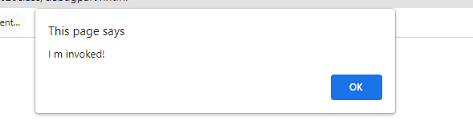

2.

window.alert("I'm JavaScript!");

window.alert("I'm JavaScript!");

window.alert('Hello') // this line is not having semicolon

window.alert('World')

alert(3 +1+ 2); // this is multiple line code and its working

Output;

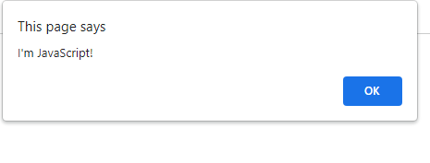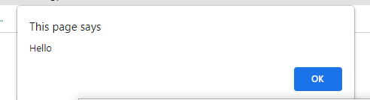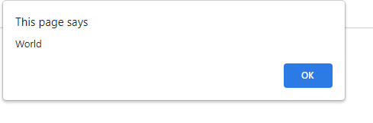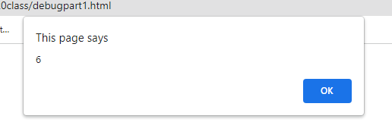

3.

let admin=9, fname=10.5;

fname = "Guvi";

lname = "geek";

admin = fname+" "+lname;

alert(admin); // "Guvi geek"

Output:

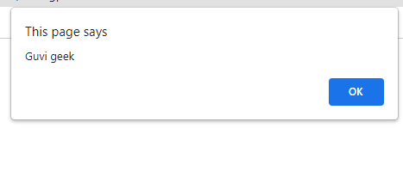

4.

let fname=10.5;

fname = "Guvi";

lname = "geek";

let name2 = fname+lname;

alert( "hello" + name2);

Output:

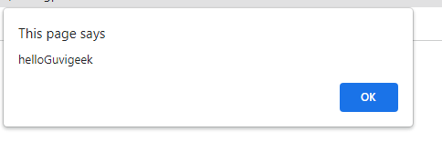

5.

let a = prompt("First number");

let b = prompt("Second number");

let sum=parseFloat(a)+parseFloat(b);

window.alert(sum);

Output:

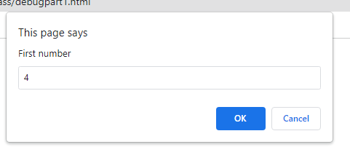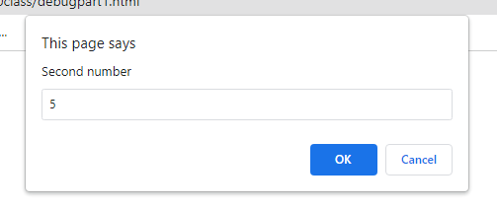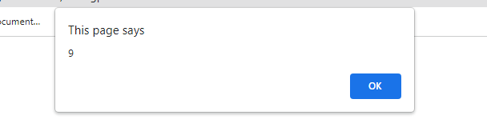

6.

let a = prompt("First number?");

let b = prompt("Second number?");

alert(a + b);

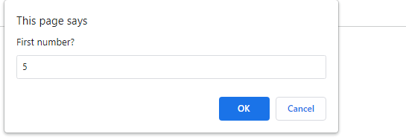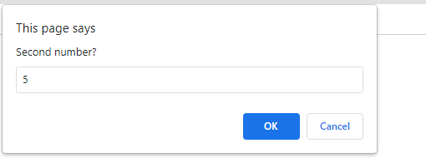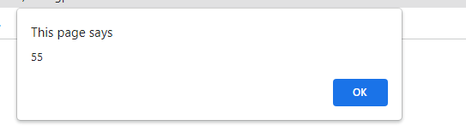

7.

var a = 2 > 12;

//Don't touch below this

if (a) {

console.log("Code is Blasted")

}

else

{

console.log("Diffused")

}

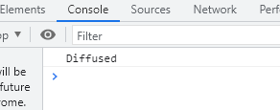

8.

let a= 3 > 14

//Don't modify any code below this

if (a) {

console.log( 'OMG it works for any number inc 0' );

}

else

{

console.log( "Success" );

}

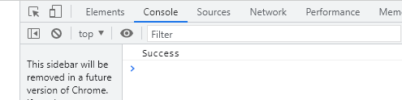

9.

let value = prompt('How many runs you scored in this ball');

switch (value) {

case '1':console.log("single runs");

break;

case '2':console.log("two runs");

break;

case '3':console.log("three runs");

break;

case '4':console.log("four");

break;

case '5':console.log("five runs");

break;

case '6':console.log("six runs");

break;

default: console.log("dotball");

}

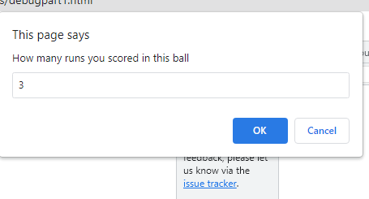

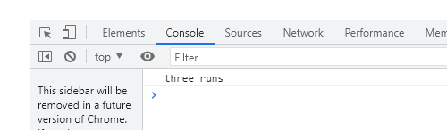

10.

let login = 'Employee';

let message = "welcome to"

console.log(message+" "+login)

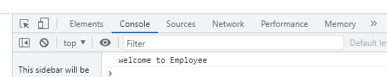

11.

let message;

if (null || 2 )

{

message = "welcome boss";

}

else

{

message = "Go away";

}

console.log(message);

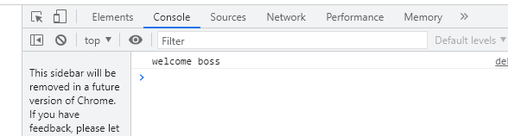

12.

let message;

let lock = null;

//Dont change any code below this

if (null || lock || undefined )

{

message = "Go away";

}

else

{

message = "welcome";

}

console.log(message);

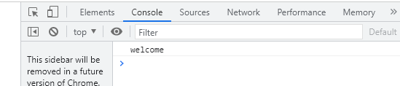

13

let message ="boss";

let lock = null;

//Dont change any code below this

if (lock && " " || undefined )

{

message = "Go away";

}

else

{

message = "welcome";

}

console.log(message);

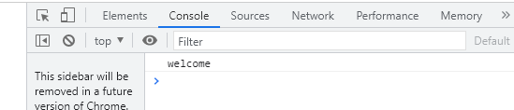

14

You can change only 2 characters

let i = 3;

while (i) {

console.log( i-- );

}

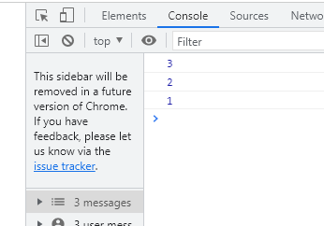

15.

let num = 1

console.log(num)

num += 1

console.log(num)

num += 1

console.log(num)

num += 1

console.log(num)

num += 1

console.log(num)

num += 1

console.log(num)

num += 1

console.log(num)

num += 1

console.log(num)

num += 1

console.log(num)

num += 1

console.log(num)

let sum=0;

for(let i=1;i<=4;i++)

{

for(let j=i; j>=1; j--){

console.log(j)

}

}

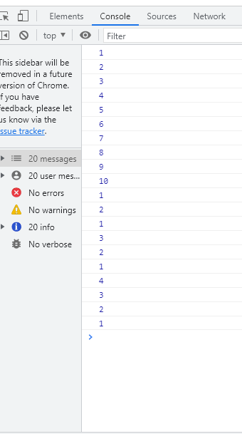

16,

for (let i = 1; i <= 20; i+= 1) {

if(i%2==0){

console.log(i,"even")

}

}

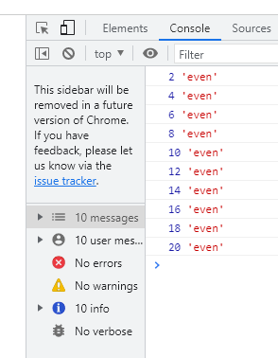

17

let gifts = ["teddy bear", "drone", "doll"];

for (let i = 0; i < 3; i++) {

console.log(gifts[i]);

}

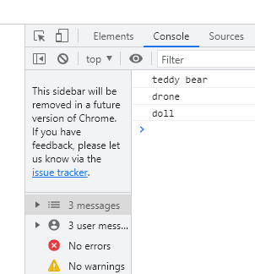

18.

let countdown = 100;

while (countdown > 70) {

countdown--;

if(countdown == 0)

{

console.log("bomb triggered");

}

else{

console.log("bomb disarm")

}

}

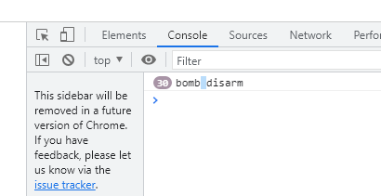

19

var lemein = "0";

var lemeout = 0;

var msg = "";

if (lemein) {

msg += "hi";

}

if (lemeout) {

msg += 'Hello';

}

console.log(msg);

var declear number in the format ""

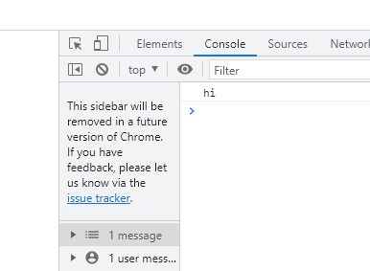

20.

var lemein = "0";

var lemeout = 0;

var msg = "";

if (lemein) {

msg += "hi";

}

if (lemeout) {

msg += 'Hello';

}

console.log(msg);

var declear number in the format ""

